Task-4

Project Report: Mechanical Gear Linkage Assembly

1. Project Overview
This project involves the design and 3D modeling of a mechanical gear linkage assembly. The system consists of a central link (connecting bar) that integrates two outer spur gears and a central mounting or alignment interface. This type of mechanism is commonly utilized in compact power transmission systems, timing mechanisms, or localized gear trains where precise relative motion between adjacent rotating elements must be maintained within a fixed structural constraint.

2. Component Breakthrough & Architecture
Based on the geometric hierarchy within the assembly data, the model is built from several distinct shapes structured using FreeCAD’s assembly constraints:
The Linkage Plate (Central Carrier): A rigid, flat structural plate with rounded ends that fixes the center-to-center distance between the rotating components. It features:
Two outer precision bores for locating the gear pivot shafts.
A centralized hub featuring an internal concentric bore.
Symmetrical weight-reduction or specialized interlocking cutouts between the center and outer hubs.
Spur Gears (Mated Pair): Two identical external-tooth spur gears positioned at opposite ends of the linkage carrier. The in-volute tooth profile ensures smooth conjugate gear action, maintaining uniform velocity transmission if driven by external shafts.

3. CAD Workflow & Modeling Methodology
The assembly was developed utilizing parametric modeling principles within FreeCAD. The workflow follows a systematic, bottom-up design methodology:

Step 1: Sketching and Base Geometry
The fundamental profile of the linkage carrier was generated in the Sketcher Workbench on a primary Cartesian plane.
Geometric constraints (coincidence, symmetry, and tangency) along with dimensional constraints were enforced to ensure the layout remains robust to parametric updates.

Step 2: Part Generation via Feature Extraction
Pad Operations: The 2D sketches of both the linkage plate and the gear blanks were extruded to specified uniform thicknesses using the Pad tool within the Part Design Workbench.
Pocket Operations: The concentric center bores, outer shaft locations, and specialized cutouts were created by sketching on the extruded faces and using the Pocket tool to cut through the solid geometry.
Gear Generation: The intricate in-volute tooth profiles were systematically distributed around the gear pitch circles using a circular pattern tool or native parametric gear creation macros.

Step 3: Assembly and Spatial Orientation
The individual component shapes were brought into a unified workspace.
Spatial positioning, alignment vectors, and rotation matrices were applied to establish the correct mating constraints, ensuring the gears mesh properly without volumetric interference.

4. Analysis of the Output Model
The finalized rendering showcases a clean, high-fidelity engineering model:
Feature | Assessment / Value
Symmetry | Excellent bilateral symmetry along both the longitudinal and transverse axes of the linkage plate.
Mesh Quality | Clean topological boundaries with sharp edges and well-defined cylindrical faces for mechanical interfaces.
Design Intention | The compact integration of the link with the gear profiles suggests a high-density mechanical drive layout optimized for localized angular motion or timing control.

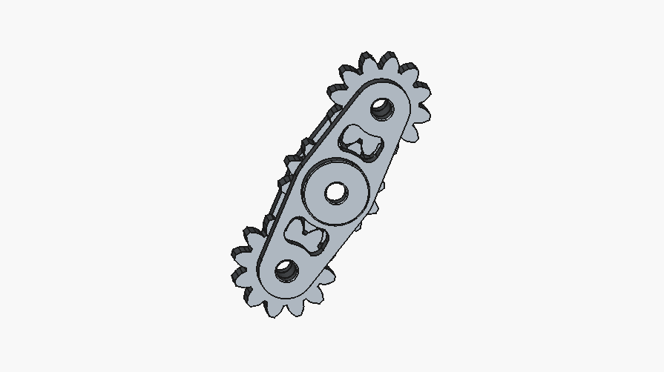

5. Summary Conclusion
The workflow successfully demonstrates advanced parametric design capabilities, taking a complex mechanical arrangement from 2D constrained sketches to a fully realized, multi-part assembly file. The model is fully prepared for downstream engineering applications, including kinematic motion simulations, Finite Element Analysis (FEA) for structural stress evaluation, or exportation to stereolithography formats for additive manufacturing and CNC machining prototypes.

